Name: GADDE TEJA SAI
Roll No: AP25110070720
Subject: Data structure
Assignment: Lab Task-6
GitHub Link: https://github.com/tejasaigadde
Q.) Implementation the following operations: enqueue, dequeue and finding an element:
- Linear Queue using arrays.
CODE:
#include <stdio.h>
#define MAX 5

int queue[MAX];
int front = -1, rear = -1;

void enqueue() {
int value;
if (rear == MAX - 1) {
printf("Queue Overflow\n");
} else {
printf("Enter value to insert: ");
scanf("%d", &value);
if (front == -1)
front = 0;
queue[++rear] = value;
printf("Inserted successfully\n");
}
}

void dequeue() {
if (front == -1 || front > rear) {
printf("Queue Underflow\n");
} else {
printf("Deleted element: %d\n", queue[front]);
front++;
}
}

void search() {
int key, found = 0;
if (front == -1 || front > rear) {
printf("Queue is Empty\n");
return;
}

printf("Enter element to search: ");
scanf("%d", &key);

for (int i = front; i <= rear; i++) {
if (queue[i] == key) {
printf("Element found at position %d\n", i);
found = 1;
break;
}
}

if (!found)
printf("Element not found\n");
}

void display() {
if (front == -1 || front > rear) {
printf("Queue is Empty\n");
} else {
printf("Queue elements: ");
for (int i = front; i <= rear; i++)
printf("%d ", queue[i]);
printf("\n");
}
}

int main() {
int choice;

do {
printf("\n--- Linear Queue Menu ---\n");
printf("1. Enqueue\n");
printf("2. Dequeue\n");
printf("3. Search\n");
printf("4. Display\n");
printf("5. Exit\n");
printf("Enter your choice: ");
scanf("%d", &choice);

switch (choice) {
case 1: enqueue(); break;
case 2: dequeue(); break;
case 3: search(); break;
case 4: display(); break;
case 5: printf("Exiting...\n"); break;
default: printf("Invalid choice\n");
}
} while (choice != 5);

return 0;
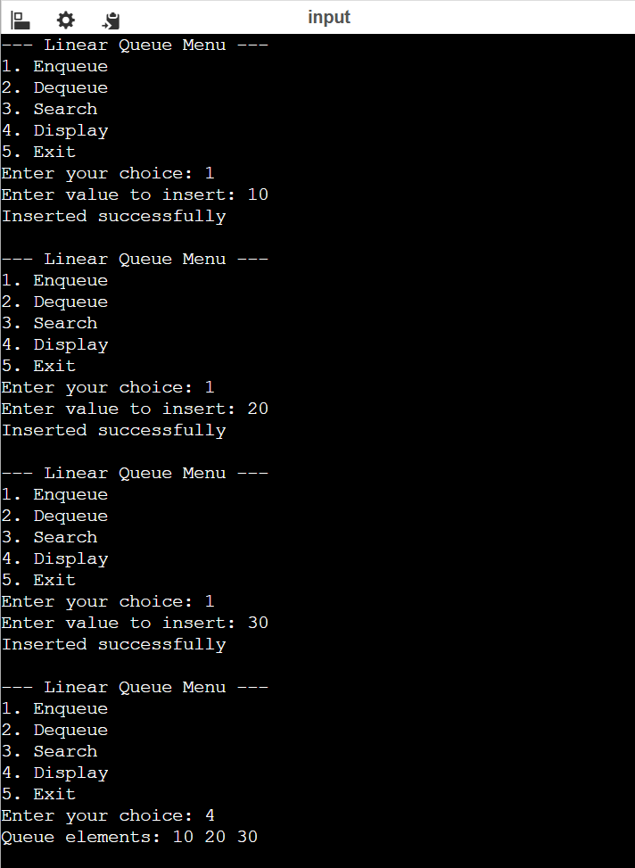
}
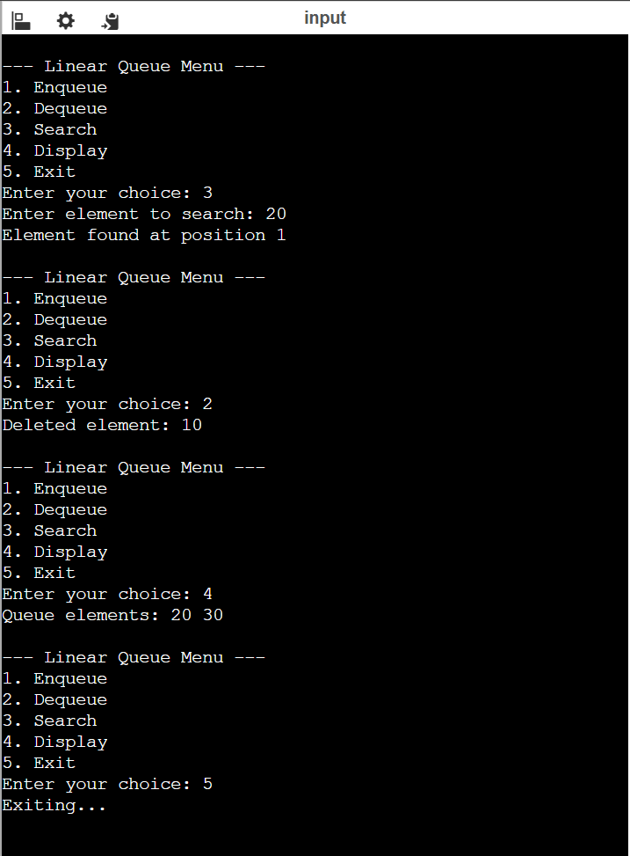
- Circular queue using arrays
CODE:
#include <stdio.h>
#define MAX 5

int queue[MAX];
int front = -1, rear = -1;

void enqueue() {
int value;

if ((rear + 1) % MAX == front) {
printf("Circular Queue Overflow\n");
} else {
printf("Enter value to insert: ");
scanf("%d", &value);

if (front == -1)
front = 0;

rear = (rear + 1) % MAX;
queue[rear] = value;

printf("Inserted successfully\n");
}
}

void dequeue() {
if (front == -1) {
printf("Circular Queue Underflow\n");
} else {
printf("Deleted element: %d\n", queue[front]);

if (front == rear)
front = rear = -1;
else
front = (front + 1) % MAX;
}
}

void search() {
int key, i, found = 0;

if (front == -1) {
printf("Queue is Empty\n");
return;
}

printf("Enter element to search: ");
scanf("%d", &key);

i = front;
while (1) {
if (queue[i] == key) {
printf("Element found at index %d\n", i);
found = 1;
break;
}
if (i == rear)
break;
i = (i + 1) % MAX;
}

if (!found)
printf("Element not found\n");
}

void display() {
int i;

if (front == -1) {
printf("Queue is Empty\n");
} else {
printf("Queue elements: ");
i = front;
while (1) {
printf("%d ", queue[i]);
if (i == rear)
break;
i = (i + 1) % MAX;
}
printf("\n");
}
}

int main() {
int choice;

do {
printf("\n--- Circular Queue Menu ---\n");
printf("1. Enqueue\n");
printf("2. Dequeue\n");
printf("3. Search\n");
printf("4. Display\n");
printf("5. Exit\n");
printf("Enter your choice: ");
scanf("%d", &choice);

switch (choice) {
case 1: enqueue(); break;
case 2: dequeue(); break;
case 3: search(); break;
case 4: display(); break;
case 5: printf("Exiting...\n"); break;
default: printf("Invalid choice\n");
}
} while (choice != 5);

return 0;


